SIMATS ENGINEERING
SAVEETHA INSTITUTE OF MEDICAL AND TECHNICAL SCIENCES
CHENNAI – 602105
Department of Computer Science and Engineering

ASSESSMENT TOOL 3 – Correlation and Pattern Analysis

Course Code: | DSA0502 | Course Title: | Query Processing for Data Science
CO Assessed: | CO4 | Assessment: | Tool 3– Correlation and Pattern Analysis
Weightage: | 25% | Total Marks:
CO4 Statement: Explore datasets using analytical techniques such as grouping, correlation detection, joining datasets, and extracting meaningful insights.
Student Name: | G Rajasekhar Reddy | Reg. No.: | 192424216
Section / Batch: | BTech-AI&DS | Date of Submission: | 20/08/2026
Faculty In-charge: | Dr. B.Shyamala Gowri | Project Mode: | Individual Submission

Code of Conduct
I G Rajasekhar Reddy(192424216) (Name / Reg No) certify that this submission is my original work and that I have adhered to all guidelines specified for this assessment. I understand that any violation of academic integrity rules will result in disciplinary action.
Signature: G Rajasekhar Reddy

- Correlation Analysis of Student Performance
Import student datasets containing attendance, assignment marks, internal marks, study hours, and final marks. Explore the tables, join relevant datasets, calculate correlations between variables, identify outliers, and use appropriate charts to explain the major patterns in student performance.

Aim:

To import student datasets containing attendance, assignment marks, internal marks, study hours, and final marks, join the relevant datasets, calculate correlations between variables, identify outliers, and visualize the major patterns in student performance.

Program:

import pandas as pd
import matplotlib.pyplot as plt
import seaborn as sns

# Read datasets
attendance = pd.read_csv("student_attendance.csv")
marks = pd.read_csv("student_marks.csv")

# Join datasets
df = pd.merge(attendance, marks, on="StudentID")

print("COMBINED DATA")
print(df.head())

print("\nDATASET SHAPE")
print(df.shape)

# Correlation
print("\nCORRELATION")
print(df[
["Attendance", "AssignmentMarks", "InternalMarks",
"StudyHours", "FinalMarks"]
].corr())

# Outlier detection
Q1 = df["FinalMarks"].quantile(0.25)
Q3 = df["FinalMarks"].quantile(0.75)

IQR = Q3 - Q1

lower = Q1 - 1.5 * IQR
upper = Q3 + 1.5 * IQR

outliers = df[
(df["FinalMarks"] < lower) |
(df["FinalMarks"] > upper)
]

print("\nNUMBER OF OUTLIERS")
print(len(outliers))

print("\nOUTLIERS")
print(outliers[["StudentID", "FinalMarks"]])

# Average marks by attendance group
df["AttendanceGroup"] = pd.cut(
df["Attendance"],
bins=[0, 75, 85, 100],
labels=["Low", "Medium", "High"]
)

print("\nAVERAGE FINAL MARKS BY ATTENDANCE GROUP")
print(df.groupby("AttendanceGroup", observed=True)["FinalMarks"].mean())

# Scatter plot
plt.scatter(df["StudyHours"], df["FinalMarks"])

plt.title("Study Hours vs Final Marks")
plt.xlabel("Study Hours")
plt.ylabel("Final Marks")
plt.tight_layout()
plt.show()

# Correlation heatmap
sns.heatmap(
df[
["Attendance", "AssignmentMarks", "InternalMarks",
"StudyHours", "FinalMarks"]
].corr(),
annot=True
)

plt.title("Student Performance Correlation")
plt.tight_layout()
plt.show()

# Outlier box plot
sns.boxplot(y=df["FinalMarks"])

plt.title("Final Marks Outlier Detection")
plt.ylabel("Final Marks")
plt.show()

Output:

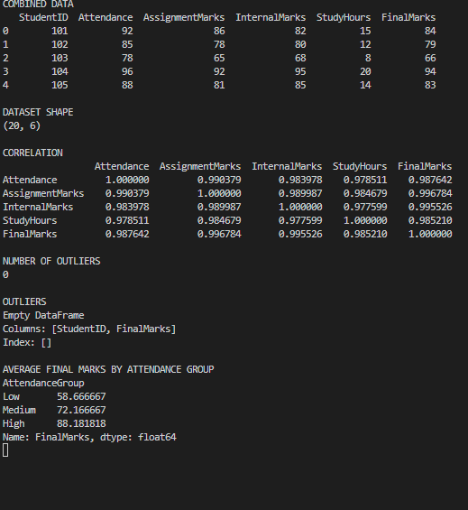

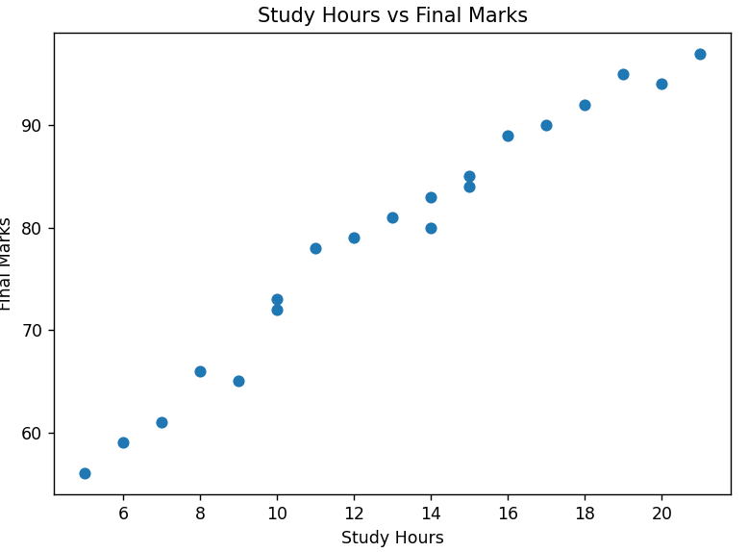

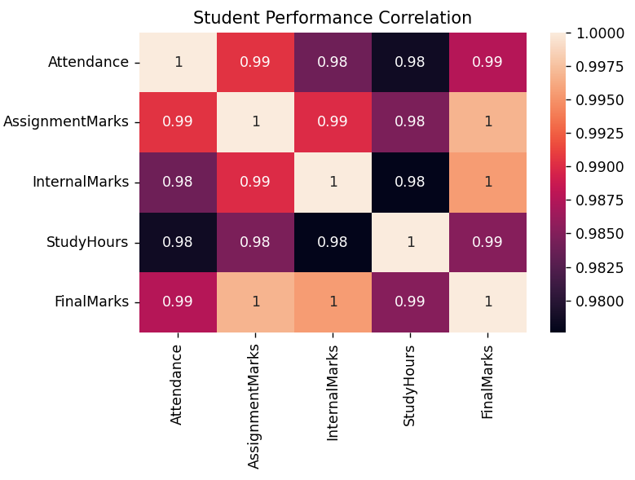

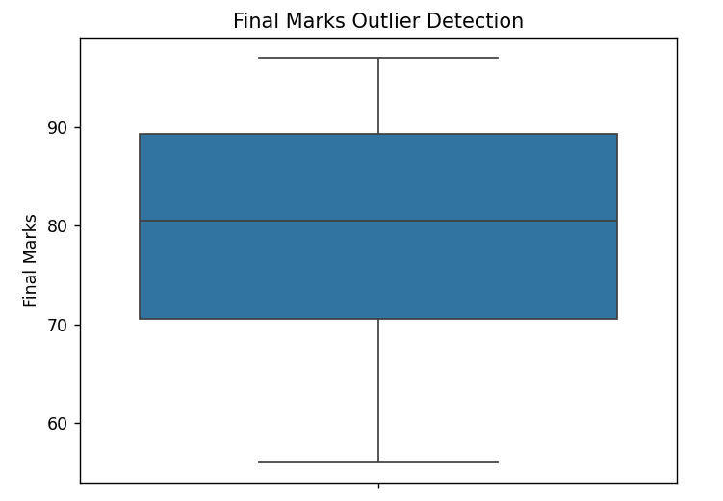

- Sales and Customer Pattern Analysis
Import sales and customer datasets and combine them using suitable table-joining techniques. Analyze the correlation between customer age, purchase frequency, discount, and purchase amount. Create meaningful customer groups, identify unusual purchasing patterns, and present the results using suitable visualizations.

Aim:
To import sales and customer datasets, combine them using suitable table-joining techniques, analyze the correlation between customer age, purchase frequency, discount, and purchase amount, create meaningful customer groups, identify unusual purchasing patterns, and present the results using suitable visualizations.

Program:

import pandas as pd
import matplotlib.pyplot as plt
import seaborn as sns

# Read datasets
customers = pd.read_csv("customers.csv")
sales = pd.read_csv("sales.csv")

# Join datasets
df = pd.merge(customers, sales, on="CustomerID")

print("COMBINED DATA")
print(df.head())

print("\nDATASET SHAPE")
print(df.shape)

# Correlation
print("\nCORRELATION")
print(df[
["Age", "PurchaseFrequency", "Discount", "PurchaseAmount"]
].corr())

# Customer grouping
df["CustomerGroup"] = pd.cut(
df["PurchaseAmount"],
bins=[0, 1000, 3000, 10000],
labels=["Low Value", "Medium Value", "High Value"]
)

print("\nCUSTOMER GROUPS")
print(df.groupby("CustomerGroup", observed=True)["PurchaseAmount"].mean())

# Top customers
print("\nTOP 10 CUSTOMERS BY PURCHASE AMOUNT")
print(
df.sort_values(
"PurchaseAmount",
ascending=False
)[["CustomerID", "Age", "PurchaseAmount"]].head(10)
)

# Unusual purchasing patterns using IQR
Q1 = df["PurchaseAmount"].quantile(0.25)
Q3 = df["PurchaseAmount"].quantile(0.75)

IQR = Q3 - Q1

lower = Q1 - 1.5 * IQR
upper = Q3 + 1.5 * IQR

unusual = df[
(df["PurchaseAmount"] < lower) |
(df["PurchaseAmount"] > upper)
]

print("\nNUMBER OF UNUSUAL PURCHASES")
print(len(unusual))

print("\nUNUSUAL PURCHASES")
print(
unusual[
["CustomerID", "PurchaseFrequency", "Discount", "PurchaseAmount"]
]
)

# Scatter plot
plt.scatter(
df["PurchaseFrequency"],
df["PurchaseAmount"]
)

plt.title("Purchase Frequency vs Purchase Amount")
plt.xlabel("Purchase Frequency")
plt.ylabel("Purchase Amount")
plt.tight_layout()
plt.show()

# Correlation heatmap
sns.heatmap(
df[
["Age", "PurchaseFrequency", "Discount", "PurchaseAmount"]
].corr(),
annot=True
)

plt.title("Customer Purchase Correlation")
plt.tight_layout()
plt.show()

# Customer group chart
df.groupby(
"CustomerGroup",
observed=True
)["PurchaseAmount"].mean().plot(kind="bar")

plt.title("Average Purchase Amount by Customer Group")
plt.xlabel("Customer Group")
plt.ylabel("Average Purchase Amount")
plt.xticks(rotation=0)
plt.tight_layout()
plt.show()

# Outlier box plot
sns.boxplot(y=df["PurchaseAmount"])

plt.title("Unusual Purchase Detection")
plt.ylabel("Purchase Amount")
plt.show()

Output:

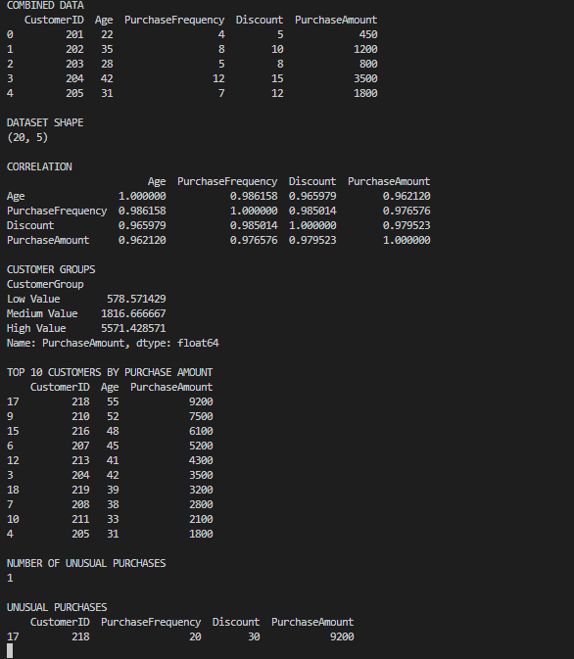

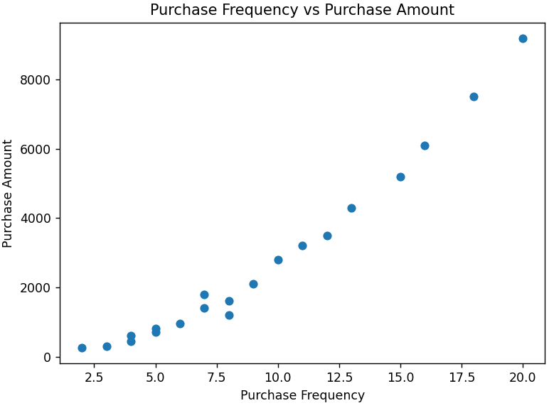

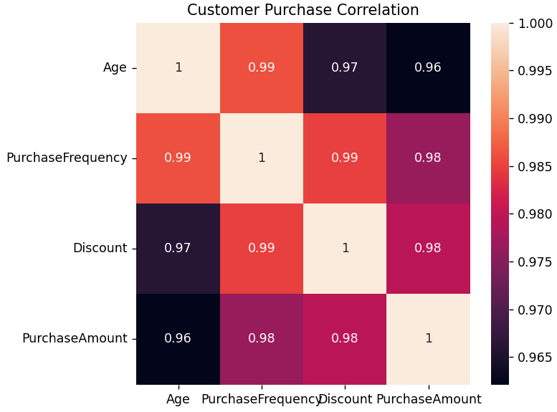

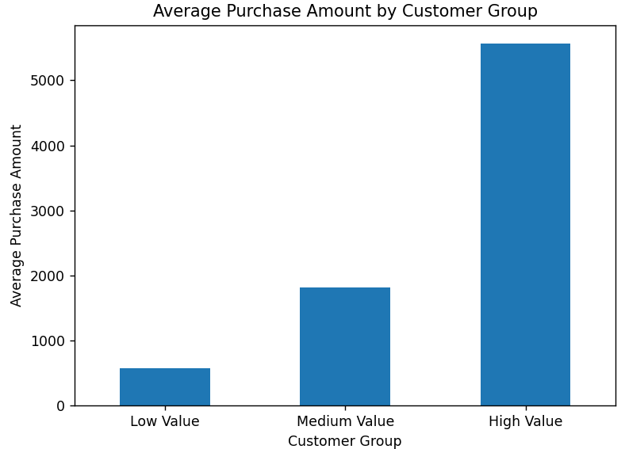

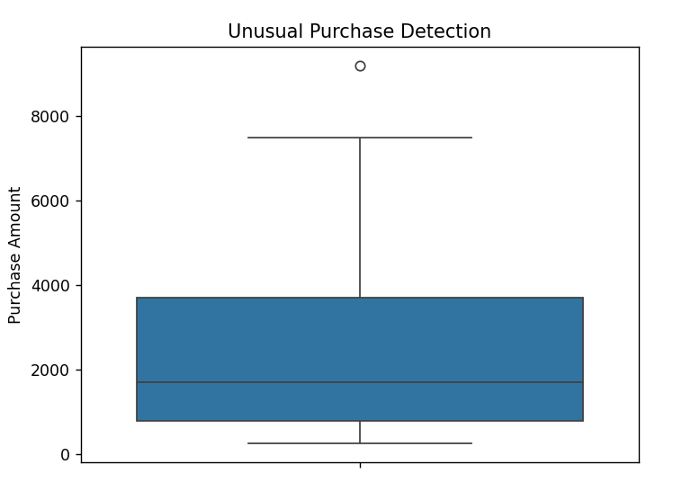

窗体底端

